Lab Report 1

*Name: Sricharan Vinoth Kumar*

*Roll no: 2024112022*

*Group no: 10*

Experiment 1:

* Objective:

To become conversant with the features of the Digital Test Kit and understand the implications of binary logic levels.

* Electronic Components Used:
  + Digital Test kit
  + 74HC04 Hex Inverter IC
  + Wires
* Reference Circuit:

* Procedure:
  1. Familiarize yourself with the working and the schematic of the given breadboard.
  2. Ensure that the CLOCK of the kit is placed in the FAST position and switch on the VCC supply.
  3. Verify the working of the input pins IP1-IP12 and the output LEDs LR1-LR8 and LG1-LG8, by connecting them with the wires given.
  4. Attach the given 7404 IC to the breadboard across the center line.
  5. Connect the VCC and GND pins of the IC to the VCC and GND ports of the kit.
  6. Connect any one of the input pins of the IC to any of the input pins IP1-IP12 and the corresponding output pin of the IC to any of the output pins DP1-DP8.
  7. Verify the functionality of the NOT gate by drawing a truth table for the outputs.
* Conclusion:

The working of the NOT gate has been verified. The functionality of the given test kit has been familiarized with.

* Tinkercad Simulation:

<https://www.tinkercad.com/things/fkvn6MAHZuI-dsm-lab-1-exp-1?sharecode=Qh2OpenpCigOn6UpL-0HmTfJ-tfZDHLnLoCGtp7BZD4>

Experiment 2:

* Objective:

To print “Hello World” on the Serial Monitor of the Arduino when the input from the NOT gate is 1 and nothing when the input is 0.

* Electronic Components Used:
  1. Arduino Uno
  2. Digital Test Kit
  3. 74HC04 Hex Inverter IC
  4. Wires
* Reference Circuit:

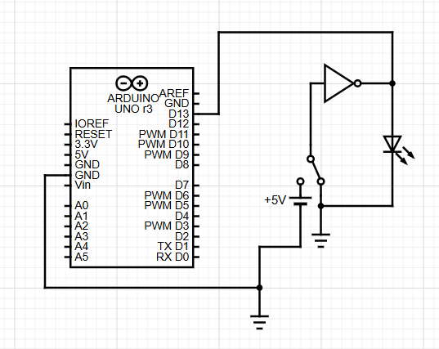

* Code:

void setup()

{

pinMode(13, INPUT);

Serial.begin(9600);

}

void loop(){

if (digitalRead(13)){

Serial.println("Hello World");

}

}

* Procedure:

1. Ensure that the CLOCK of the kit is in the fast position and turn the VCC supply on.
2. Verify the working of the input pins IP1-1P12 and the output LEDs LR1-LR8 and LG1-LG8, by connecting them with the wires given.
3. Attach the given 7404 IC across the center line of the breadboard.
4. Connect the VCC and GND pins of the IC to the VCC and GND pins of the kit.
5. Connect any one of the input pins of the IC to any one of the input switches of the kit, and the corresponding output pin of the IC to Digital pin 13 of the Arduino (or any other pin, depending on the code) and to any one of the output LEDs of the kit.
6. Upload the code to the Arduino and open the Serial Monitor.
7. Verify whether the Monitor prints “Hello World” when the output of the NOT gate is 1, using the output LED.

* Conclusion:

The Serial Monitor prints “Hello World”, when the output of the NOT gate is 1 and nothing when the output is 0.

* Tinkercad Simulation:

<https://www.tinkercad.com/things/fwiS4dfEDOp-dsm-lab-1-exp-2?sharecode=ueGxvDBBSoxi8_oEhqzxTicHnKJ3Ok5DrNifiHVhcno>